**WIX3001 Soft Computing**

**Tutorial 2: Introduction to MATLAB**

1. There are two ways to use MATLAB: online through the web browser, or offline with an installer.

**2a) Using MATLAB through web browser**

1. Go to <https://www.mathworks.com/academia/tah-portal/university-of-malaya-31385608.html>

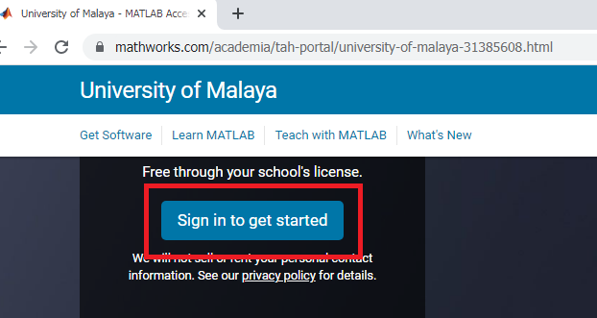

1. If you don’t have a Mathworks account, create one with your SiswaMail.

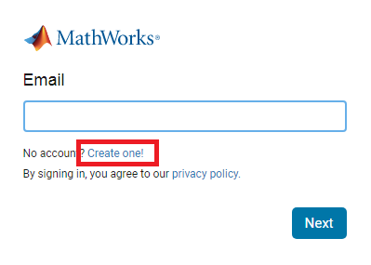

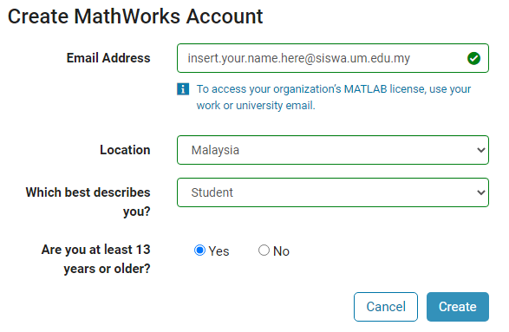

1. After you have created an account and signed in, go to <https://matlab.mathworks.com> .

**2b) Using MATLAB from installer**

1. Follow the instructions in <https://www.um.edu.my/faq-ict-software>

**2c) Introduction to MATLAB**

1. You will see three windows: Command Window, Files, and Workspace.

For tutorials, you will be required to submit a file as proof of your attendance.

To create the file, type in the Command Window:

|  |
| --- |
| diary “tutorial_week3_your_student_ID” |

Replacing “your_student_ID” with your student ID.

At the end of the tutorial, close the file by typing

|  |
| --- |
| diary off |

Then right-click the file under Files and download it. Then email it to [liew.wei.shiung.phd@um.edu.my](mailto:liew.wei.shiung.phd@um.edu.my) . This will count as your attendance for this tutorial.

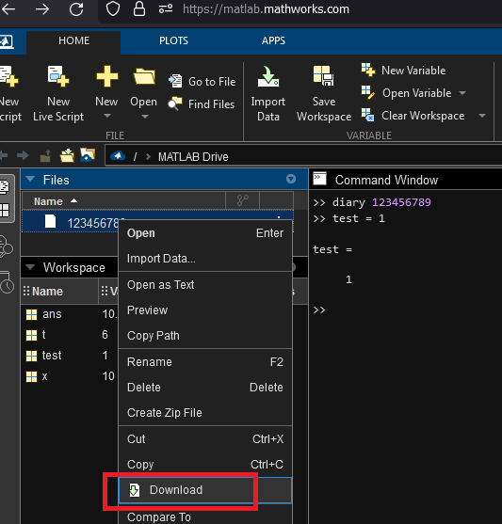

1. Go through the ebook “Introduction to MATLAB”, starting from Chapter 2.

Finish as much as you can in the tutorial class and then submit the “tutorial_” file.

1. For this week’s homework, finish the rest of Chapter 2.

Create the diary file before you begin: “homework_week3_your_student_ID”.

After you complete Chapter 2, submit the diary file to my email.